“Free In Deed”
The Bi-Monthly newsletter of Central California Jail/Prison Ministry

Volume 7– Jan. 2005 / Feb. 2005

“I Can Only Imagine”

In this Volume 7 issue, we would like to ask, “When was the last time you prayed with a prisoner?” Does the term prisoner have a connotation tied with it? What about the fact that Paul, the disciple, was a prisoner? How would we feel about praying with Paul? Who determines the potential of these inmates?
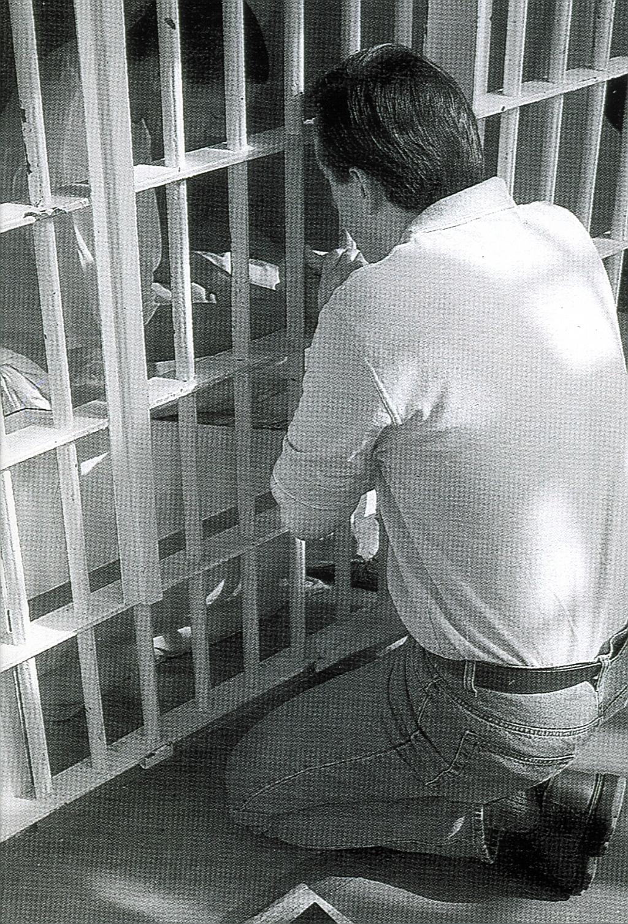

I can honestly say that some of these individuals are reached. And God’s Word commands us to preach the Word in its entirety, with boldness and with no apologies for what it says.

Intentions & Wishes
We have gone to Bi-Monthly because there is too much to share. The intentions of this newsletter are to allow an understanding of jail & prison ministries. It is our intentions to get input from those incarcerated as well as those “free” to visit. Life experiences of the faith and fellowship from those locked up in the facilities are always desired to let others know of the value of “visitation”. I am certain that each of us have many stories of the miracles God has done in our lives.
Our wishes are that we would have a list of supportive churches that individuals might look forward to attending once released.
A list of services, such as housing, employment, and counseling services, as well as some individuals available for friendly fellowship are also much needed items.
God’s Word says if a man stumbles, how can he continue lest there be another to help him up. Ecc. 4:10 “For if they fall, the one will lift up his fellow: but woe to him [that is] alone when he falleth; for [he hath] not another to help him up.” Proverbs 24:17 “Rejoice not when thy enemy falleth, and let not thy heart be glad when he stumbleth:” John 11:10 “But if a man walketh in the night, he stumbleth, because there is no light in him.”

Please help us with input for this news letter as we strive to serve God. We appreciate any articles, testimonies, or input.
Letters that Express it All

These are actual quotes from some of the different incarcerated individuals. The names have been removed

“If it were not for good Christian people like yourself, many lonely prisoners like myself would have given up hope . . .“I am so happy now that someone truly cares for me. Right now I’m going through some anxiety and depression problems, but with the help of God, and people like yourself who are willing to take the time to pray for us and visit us, I can truly say that God and other Christians do care.

“Just received your newsletter. It was very interesting. It also has a lot of answers to things I’ve often wondered but never asked. For instance, page #5 in the newsletter “Am I Really Saved.” (reprinted on page #5 of this newsletter) This was good to receive this. It has answered my questions and I have Christ as my personal savior. I feel really good inside. The Holy Spirit is developing inside me . . .”

Please pray for individuals like this, that the Lord will lead them to a true commitment.

Fellowship

We would like to keep a listing of locations for fellowship that welcomes previous incarcerated individuals. Please feel free to let us know of those available. We also cherish letters from inmates or relatives to the churches to let us know how we are doing

CHAINBREAKERS
Every Tuesday
Visalia First Assembly
3737 S. Akers
Visalia, CA.
Room 8 – 7:00 p.m.
733-9070 ext. 131

Calvary Chapel Visalia
11720 Avenue 264
Visalia, CA. 93277
687-0220

Visalia First Baptist
1100 S. Sowell
Visalia, CA. 93277
732-4787

Church of the Nazarene
3333 W. Caldwell Avenue
Visalia, CA 93277
734-1117

Praise Center Church
503 N. Floral St.
Visalia, CA. 93291
733-2744

If you would like a church added,
Please contact us.

Addresses to contact our Ministry Volunteers

Bob
P.O. Box 6667
Visalia, CA. 93290

Rick
3737 S. Akers
Visalia, CA. 93277

When Satan reminds you of your past, remind him of his future.

God accepts you where you are, but loves you too much to leave you there.

Bible Study Lessons

SET FREE PRISON MINISTRY
Of Northern California
401 MacArthur Boulevard
San Leandro, CA. 94577-9801

Replenishing

God’s Word promises to restore the years of the locust, or more simply the years previously lost.

Joel 2:25 And I will restore to you the years that the locust hath eaten, the cankerworm, and the caterpillar, and the palmerworm, my great army which I sent among you.

Recommended Reading

For the new Christian, or the individual desiring to know God, we would like to recommend the following reading.

The Gospel of John – This is a great introduction of Christ’s walk on Earth.

The Book of Romans – This gives an introduction of many of the Bible stories shared and helps build familiarity of Christ’s plan for our lives.

The Purpose Driven Life by Rick Warren – 40 chapters will change your life in 40 days

Book of Proverbs – Read one chapter a day with the chapter read being the day of the month. This will allow the book to be read almost 12 times thru the year.

Ephesians 4 – 6 – This gives the pattern for life that we should live. All 7 S’s are displayed in these 3 chapters. We are given the purpose of the gifts, changing our character, husband/wife/family relationships, and the type of life we are to live and display.

Men’s Relational Toolbox – Another fine work by Gary Smalley with both of his sons adding to this book. This book avoids “male bashing” but rather teaches men to use and modify the inner tools they have to improve their relationships.

Tools of Ministry (Part 4)

Vol. 4 newsletter we did part 1 of the tools of ministry. In it we discussed such tools as;

A pair of Python Boots
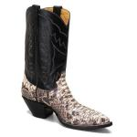

A handcrafted one-of-a-kind car,

Vol. 5 newsletter we did part 2 of the tools of the ministry
Skydiving,


And Rock climbing
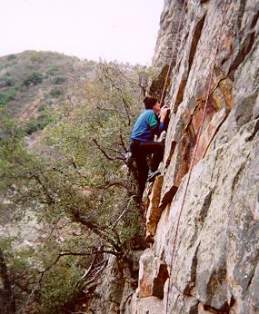
Vol. 6 newsletter we did part 3 of the tools of the ministry.

Wedding Ring

In Volume 7 I decided to talk about Goldfish
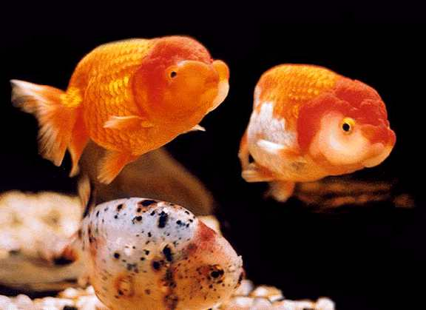
As I walk by my pond each morning, there are 7 large goldfish with their mouths opening and closing almost as though they were saying feed me. I realize people are actually like that too. As we walk by, people are often wanting to be fed. The feeding may be physical, as with the fish. But more important, the feeding may be spiritual.
Another fact is that the size the fish grow to, is determined by their container size. They were 1” long on purchase, and now are about 10”-12” long each. There was a lot of feeding and care to get to this size. Do not put limits on your environment, but rather allow yourself to grow.
Am I Really Saved?
Reprinted from Walk in the Word
Pastor James MacDonald
“The Spirit of God bears witness with our spirit that we are the children of God.” Romans 8:16
I’m kind of fired up because without a doubt, I have the most important subject in the universe to talk to you about today. If you have “it,” you have everything that you need. But without it, you don’t have anything—no matter how much you have. Many people think they have this but they don’t, and sadly many people who do have it, take it for granted. Recognized in all of its splendor you would die for it, but ironically unless you have it, you will die.
What is it that I’m talking about? It is the story of Scripture. It is the miracle of the age. It is the reason that Jesus came, died, and rose again. Sinners call it conversion; theologians call it justification. Children call it, asking Jesus into their hearts, and Jesus called it, being born again. Most frequently the Bible calls it salvation.
Rightly understood, salvation is the crown jewel of Christianity and the constant comfort of the Lord’s people. But it can also cause much confusion. In fact, surprisingly even in churches that preach the biblical message of salvation, a lot of people are confused about exactly what salvation is and how it works.
This week on the broadcast, I’ll clear up three crucial issues about salvation:
1. How is a person saved? How does it happen?
2. How do you know if you’ve been saved?
3. Can you lose your salvation?
Right now, we’ll focus on the second issue, how can you be absolutely sure that you’ve been saved?
If you’re saved, you belong to God. God has made a mark on you. He has sealed you. What is that assurance that you belong to Him? Look at Ephesians 1:13: “Having believed you were sealed with the Holy Spirit.” So here it is—if you’ve been saved, you have the Holy Spirit. If you’re not saved, you don’t have the Holy Spirit. So the question then is, how do I know if I have the Holy Spirit?
We’re gonna get this settled right now. Are you saved? If you’re saved, the Holy Spirit is doing these six things in your life. There’s many more things we could have included on this list but I chose what I thought were the six main ones.
1. The Holy Spirit is growing you. (Galatians 5:22) If you’re saved, you’re more godly than you used to be. You’re changing. You might have symptoms of your old problems but you don’t give into them like you used to. You’re being set free from addictions. Your character is growing. When you are saved, the Spirit is developing in you “... love, joy, peace, longsuffering, gentleness, goodness, faith, self-control”—fruit of His character.
I’ll use myself as an example here. I’ve got problems; I’m not perfect. But the people who know me best, my family, my close friends, the people that I work with, all would say in unison, “James is not who he was five years ago. God’s growing and changing him.” Is God growing and changing you? That’s a work of His Spirit.
2. The Holy Spirit has gifted you. (1 Corinthians 12) When the Spirit of God comes into your life He gives you the desire and the ability to serve God. If you’re saved, He has gifted you with a specific way you can serve the body of Christ. You are prompted to get beyond selfish consumer Christianity and into the center of what He is doing to build His kingdom.
3. The Holy Spirit convicts you of sin. (John 16:8) You’re like, “It’s the craziest thing, man. Before I knew Christ I could lie, and steal, and be mean to my sister-in-law, but never even felt bad about it. Since I got saved, every time I do anything wrong this siren goes off inside me.” That’s the Spirit at work, convicting you of sin. If you can sin and not be grieved, ask yourself if you’re really saved.
4. Hunger for truth. (John 16:13) Was there a time when you couldn’t have cared less about the Bible? If somebody said to you, ‘Are you reading the Bible?’ you would have been, ‘No, I’m reading Louie L’Amour right now.’ But when you got saved, your desire to learn this book exploded in your heart. If that’s going on in your life, that’s a very good sign.
5. The Holy Spirit leads you. (Romans 8:14) What does that mean? God’s Spirit prompts you to make things right with others, to respond to the message that you hear at church, to want to do the thing that honors Him. When you’re being led by the Spirit, you know there’s something going on in your heart. “As many as are led by the Spirit of God these are the children of God.”
6. The Holy Spirit comforts you. (John 14:16) Has there ever been a time in your life when you struggled with just about everything? But since you came to know Christ, things don’t bother you as much. The Spirit supplies strength that you didn’t have before and you’re now able to get through things that you couldn’t before. God Himself bears you along and helps you get through the tough stuff. That’s one of the things the Spirit of God does—He comforts us.
God wants you to know that you’re His child, and if you’re wondering about it, read Romans 8:16, “the Spirit of God bears witness with our spirit that we are the children of God.” If you’re wondering, “God, am I your child?” do this: get alone, read the Scriptures that I’ve mentioned above and pray, “God, do I really know you?” The Spirit Himself will either bear witness, “Yes” or “No.” You don’t have to wonder anymore.
Get this settled right now. If you have more questions, listen to this complete message online. No one should be confused about this issue. Know that you know that you know. It’s that important.



The Law of the Harvest

Wouldn’t life be a lot easier if you could blame everything bad that happens on your parents, on your past, on your boss, on your neighbors, on your circumstances, on your biology, on your . . . whatever? Wouldn’t it rock if we didn’t have to take any responsibility for ourselves? Scripture’s pretty clear on that ballot:
“Be not deceived . . . whatever a man sows he also reaps.” - Galatians 4:6
Most of us city slickers don’t have a clue about that sowing and reaping farm stuff. My grandfather was a farmer. My earliest memories are leaving church on Sunday and going to my grandfather’s farm. We’d play in the barn and run in the fields all afternoon.
Nowhere are the seasons more apparent than on a farm. There is winter when snow covers the hard, cold ground and everything looks dead. But guess what? Spring comes and the sun shines, the snow melts and the ground is tilled. The farmer goes out and sows seed into the field. But hang on, it’s not done yet. Then summertime comes and the sun beats down and the work gets hard and the weeding and watering must be done. Then, if the farmer has been diligent, when the fall comes—it’s harvest time! The fields are full and ripe with what he’s planted. He reaps what he has sown.
I’m sure you understand the concept but do you get the application to your life and to your family? Scripture says, whatever you plant, you harvest.
This principle begs the question: What are you planting? What have you been planting this week? In your marriage, what have you been planting? In your family, with your children, what have you been planting? In your finances, what have you been planting? In your walk with God? You say, “I’m so disappointed.” What have you been planting? Whatever you plant, you harvest.
If you planted corn, don’t be expecting wheat to come up. As hard as it is to accept, where I am today is because of the choices that I’ve made. As someone has said, “Life is 10% what happens to you and 90% how you choose to deal with it.” If we pry that open a bit further we can see that the universe operates according to principles established by Almighty God. Whatever you plant, you harvest.
You say, “Oh, that is so harsh. What about circumstances that are beyond my control?” OK, let’s be sure we know the difference between circumstances and consequences.
Circumstances are “events beyond your control resulting from forces or influences you did not cause and cannot change.”
Consequences are “resulting wholly or in part from me”—things I’ve done, things I’ve said, places I’ve gone, priorities I’ve pursued, resolutions I’ve neglected, choices I’ve made. A seed that I’ve planted is now being harvested.
I am very aware of the weight of that principle. Lest it seem in any way like this word is coming from a callused heart, please let me assure you that it is not. I believe as Jesus said that it’s the truth that sets you free. My rationalizations and excuse-making and my blaming it on others keeps me in bondage. When I step up to the plate and say, “OK, this is a consequence,” then I can begin to experience God’s grace that flows into the place of recognition and truth. This is the truth that sets you free. Far more than I ever wanted to admit, I am responsible for what I have planted and am now harvesting.
But here’s a final, very important truth. Although there is nothing you can do about last year’s harvest, you can change this year’s harvest. If you’re thinking to yourself, “Oh, James, I’ve got some really bad stuff already in the ground.” Well that’s the thing about farming—God is not mocked and there’s no crop failure coming. Ask God for the grace to persevere through those consequences and start making good choices. Be the person God wants you to be for the rest of your life. That change can start for you right now. Do you have faith to believe that God can make this a turning point for your life? When you honestly come before God with repentance, He will energize your future with grace because of your humility to acknowledge, “Hey, I’ve planted some things I regret but starting now, I want to plant a new crop.” Woohoo! When that happens, get ready for a new harvest coming.

Vows of a Christian

The following are some aspects of the vow we have with Christ. Each will be discussed lightly and hopefully create a desire to study more of what God expects of us.

Following God
Prayer
Gathering
Chastity
Tithe

Following God
Many people will talk about wanting to receive Salvation. In reality, salvation is about giving our life to Christ and following God’s directing. It is not about doing our own thing and feeling like we can get away with it because we are forgiven. The scripture states that if we “repent” and ask for forgiveness, He is faithful to forgive us. Repenting can best be described by three words – “Stop – Turn – Follow.”

Prayer
Prayer is simply talking to God. The more we talk to someone the more we understand them. Many fear praying, but it is just as talking to a stranger for the first time. God should not be a stranger in our lives. How many of us can catch a friend and talk to them for hours. When was the last time you “really” spent time with the Lord?

Gathering
“Forsake not the gathering of yourselves” is commanded by God. This gathering is also commanded of us when Christ stated “upon the first day of the week”

Chastity
When we think of chastity, we think of purity. The scripture says in I Timothy 4:12 “Let no man despise thy youth; but be thou an example of the believers, in word, in conversation, in charity, in spirit, in faith, in purity.” In Philippians 4:8 it states “Finally, brethren, whatsoever things are true, whatsoever things are honest, whatsoever things are just, whatsoever things are pure, whatsoever things are lovely, whatsoever things are of good report; if there be any virtue, and if there be any praise, think on these.” “ I Corinthians 6:9 . . . Know ye not that the unrighteous shall not inherit the kingdom of God? Be not deceived: neither fornicators, nor idolaters, nor adulterers, nor. . . ”

Tithe
“Wherein have we stolen from thee? In your tithes and offerings.” Mal. 3:8

“Give and it shall be given unto you; good measure, pressed down, and shaken together, and running over, shall men give into your bosom. For with the same measure ye mete withal it shall be measured to you again” Luke 6:38

Excuses of Sin

Sin is something we must confront head on. As with most things we hate to deal with, there is a tendency to “put off” dealing with sin in our lives. There are 5 reasons we make excuses and do not deal with sin.

Denial
When confronted with the fact that we may be living in sin, we will say “What sin?”

I John 1:10 If we say that we have not sinned, we make Him a liar, and His word is not in us.
He who says he is without sin, is a liar, and the truth is not within him.
I John 2:4 He that saith, I know him, and keepeth not his commandments, is a liar, and the truth is not in him.

I John 2:22 Who is a liar but he that denieth that Jesus is the Christ? He is antichrist, that denieth the Father and the Son.

Avoidance
Many times individuals will ignore the confrontation. Sometimes there is the avoidance by “Are you talking to me?” We need to avoid the situations of sin rather than avoiding the confrontation of sin. When confrontation comes our way out of love, we need to embrace the solutions and those bringing the solutions.

Blame Shift
Justification is often used to avoid dealing with sin. This justification, or blame shifting, is directed to others as the reason for our failing. How often do we hear, “It was because of the people I was with, they made me.”

Rationalize
Ever heard the phrase “Everybody does that?” We tend to rationalize that we are no worse than the majority of the people. We start doing comparisons of what others have done, and decide that we are not that bad. Rationalization can also be done in the opposite direction when we tend to pull up the “good things” a person has done in order to avoid confronting the sin in their life. Parents often will talk only about the accomplishments of their children and try to rationalize away the sin as being minor. In reality, sin is the major thing in our life that we must deal with.
Prov. 16:25 There is a way that seemeth right unto a man, but the end thereof [are] the ways of death.

Excuses
Another justification method is the one of excuses. Have you ever heard the statement, “Well you don’t understand what I have been through?” We make excuses because of environment, circumstances, troubled times, and even say “that is the way things were when I was growing up.”
Proper option would be “I did it” and am “guilty as charged.” God can only forgive those things that we are guilty of. If we do not admit guilt and turn away from the sins (repentance), God does not forgive. If we continue with our sins because of not being forgiven, we are not saved. The accepting of continuing on in the habitual sinning is different than the occasional sins we repent of.

